Physical And Chemical Changes

Physical Changes

Those changes that deals with change in physical properties, (shape, size, color, etc.)

Physical changes are reversible.

E.g.: Melting of Ice, Cutting of Paper, etc.

Chemical Changes

Those changes that deals with change in chemical properties, (change in chemical composition)

Chemical changes are irreversible.

E.g.: Rusting of Iron, burning of fuels, etc.

Burning of Magnesium Ribbon – A Chemical Change.

Magnesium Metal, is available in the market in the form of ribbons. Magnesium ribbons burns with a bluish white flame and leaves behind Magnesium Oxide as residue and on mixing that Magnesium Oxide with water, we get Magnesium Hydroxide which is basic in nature.

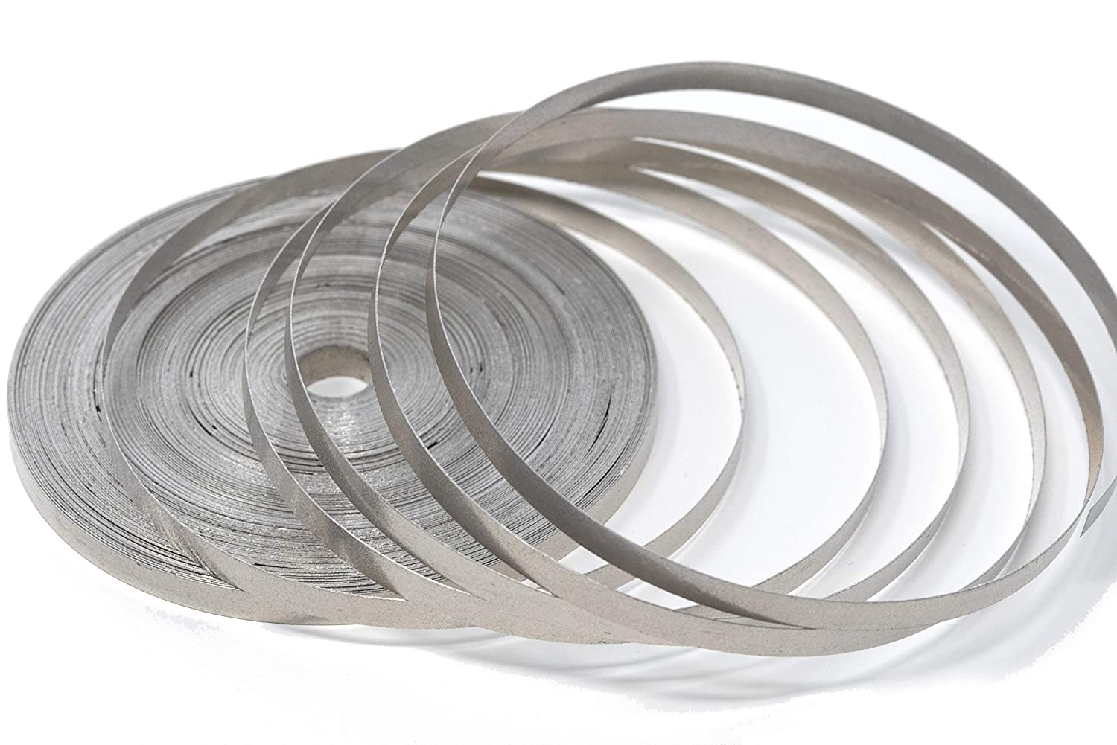

Magnesium Ribbon

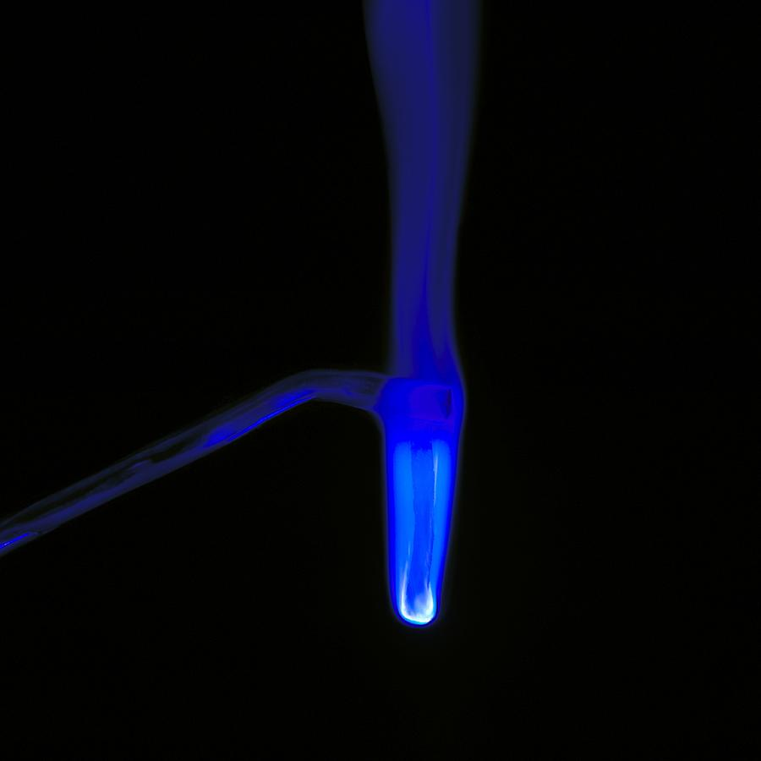

Burning of Magnesium Ribbon

Preparation of Iron (II) or Ferrous Sulphate from Copper Sulphate – A Chemical Change.

Copper Sulphate(aq) is bluish in color. On adding iron metal to the Copper Sulphate solution, the color of the solution changes from blue to green, and the copper sulphate solution gets converted to iron(ii) sulphate solution or ferrous sulphate(aq) solution.

